eTools - Rental Design

# ERD for UX process

# Possible UX Interface

### **Renting**

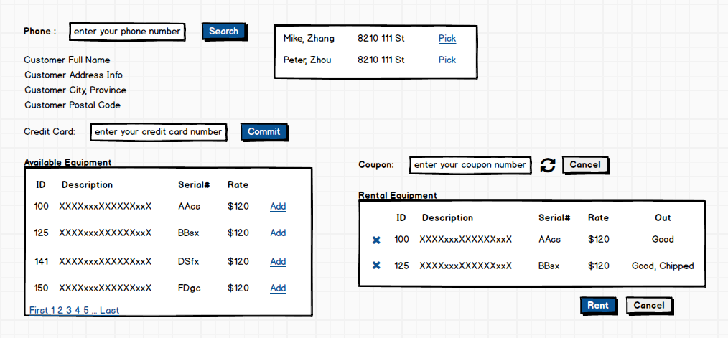

### **Returns**

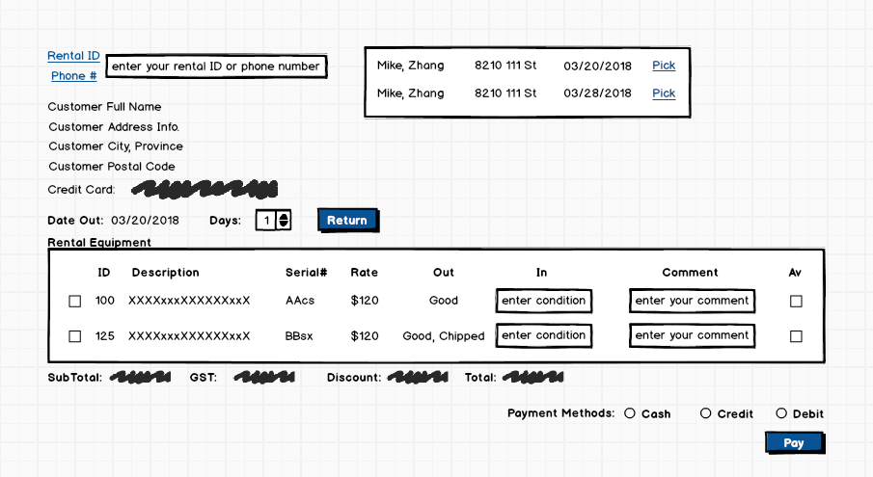

# Event and Wiring Summations

|  |  |  |
| --- | --- | --- |
| **Controls** | | **Events** |
| AddAvailableEquipment | | OnClick / wired via ObjectDataSource   * Move selection value to RentingEquipmentList, id to ArgID; * Bind data to RentalDetail |
| **BBL Class(es) and Method (s)** | | |
| RentalEquipments Controller | List<AvailableEquipmentList> List_AvailableEquipment ()  Retrieve a list of available equipments. Return available equipments infomations. Display in AvailableEquipmentList. | |
| **SQL Table(s): (C,R,U,D)** | | **Entities/DTOs/POCOs** |
| RentalEquipments (R) | | AvailableEquipmentList (P) |

|  |  |  |
| --- | --- | --- |
| **Controls** | | **Events** |
| removeRentingEquipment | | OnClick / wired via ObjectDataSource   * Move selection value to AvailableEquipmentList , DDL id to SearchArgID; * Bind data to RentalDetail |
| **BBL Class(es) and Method (s)** | | |
| RentalDetailController | List<RentingEquipmentList> List_RentingEquipment ()  Retrieve a list of renting equipments. Return renting equipments infomations. Display in RentingEquipmentList. | |
| **SQL Table(s): (C,R,U,D)** | | **Entities/DTOs/POCOs** |
| RentalDetail (R) | | RentingEquipmentList (P) |

|  |  |  |
| --- | --- | --- |
| **Controls** | | **Events** |
| RentalSearch | | OnClick |
| **BBL Class(es) and Method (s)** | | |
| CustomersController | List< CustomerList > List_CustomerInfo(int RentalID)  Retrieve a list of customer fullName, address, renting date by Rental ID. Display in CustomerList. | |
| **SQL Table(s): (C,R,U,D)** | | **Entities/DTOs/POCOs** |
| Customers (R) | | CustomerList (P) |

|  |  |  |
| --- | --- | --- |
| **Controls** | | **Events** |
| PhoneNumberSearch | | OnClick |
| **BBL Class(es) and Method (s)** | | |
| CustomersController | List< CustomerList > List_CustomerInfo(String phoneNumber)  Retrieve a list of customer fullName, address, renting date by phone number. Display in CustomerList. | |
| **SQL Table(s): (C,R,U,D)** | | **Entities/DTOs/POCOs** |
| Customers (R) | | CustomerList (P) |

|  |  |  |
| --- | --- | --- |
| **Controls** | | **Events** |
| Pay | | OnClick |
| **BBL Class(es) and Method (s)** | | |
| CustomersController | List< CustomerList > List_CustomerInfo(String phoneNumber)  Retrieve a list of customer fullName, address by phone number. Display in CustomerList. | |
| **SQL Table(s): (C,R,U,D)** | | **Entities/DTOs/POCOs** |
| RentalDetail (R) | | CustomerList (P) |

|  |  |  |
| --- | --- | --- |
| **Controls** | | **Events** |
| Return | | OnClick |
| **BBL Class(es) and Method (s)** | | |
| CustomersController | List< CustomerList > List_CustomerInfo(String phoneNumber)  Retrieve a list of customer fullName, address by phone number. Display in CustomerList. | |
| **SQL Table(s): (C,R,U,D)** | | **Entities/DTOs/POCOs** |
| RentalDetail (R) | | CustomerList (P) |

Comments

You are missing events from the rental form: customer serach, coupon verification. What is Commit on the first web form? Why two Cancels? What is Rent? You are not demonstrating or conveying an understanding of the web forms and its operations or what is happening in the controls. You have used the same method for several different business processes. **I am concerned you do not know whats going on with this subsystem.**.